**OT LAB ASSIGNMENT 5**

**Question 1**

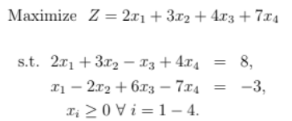

**Code:**

%% QUESTION 1

% TO OBTAIN BFS USING ALGEBRAIC METHOD

% Question

% Max Z= 2x1+3x2+4x3+7x4

% st: 2x1+3x2-x3+4x4=8

% x1-2x2+6x3-7x4=-3

% %xi>=0; i=1,2,3,4

clc

clear all

format short

% PHASE-1: Input the parameter

c=[2,3,4,7]; %Objective function

A=[2 3 -1 4; -1 2 -6 7]; %Coefficient Matrix

B=[8;3];%RHS of const

objective=1; %1 for max and -1 for minimization problem

%Number of possible solutions: nCm:nchoosek

% PHASE-2: Number of constraint and variable

m=size(A,1); %number of constraints

n=size(A,2); % number of variables

% PHASE-3: Compute the ncm Basic Solutions: The max number of basic

% solutions will always be nCm

nab=nchoosek(n,m); %total number of atmost basic solution

t=nchoosek(1:n,m); %from this we can extract our set of variables that we need to equate to zero

% PHASE-4:Construct the basic solution

% for this n>m must be satisfied

sol=[]; %default solution is zero (Empty Matrix)

if n>=m %if this is not statisfied then we can not have solutions

for i=1:nab

y=zeros(n,1);

%selecting all rows for a specific column where for t we are taking all columns for a

% specific row (which is basically the variables that are equated to zero)

X=(A(:,t(i,:)))\B;

%fetching values from A matrix for the rows correspond

%checking feasibility condition

if all(X>=0 & X~=inf & X~=-inf)

y(t(i,:))=X;

sol=[sol y];

end

end

disp("Solution: ");

disp(sol);

else

error('No. of variables is less than number of constraints')

end

if any(X == 0)

fprintf("DEGENERATE SOLUTION");

else

fprintf('NON-DEGENERATE SOLUTION\n');

end

%PHASE 5: To find optimal solution

Z=c*sol; %finding the values corresponding to each point

if(objective==1)

[Zmax,Zindex]=max(Z);%storing the max value of Z and the col in which this max value resides

else

[Zmax,Zindex]=min(Z);%storing the min value of Z and the col in which this min value resides

end

BFS=sol(:,Zindex);%basic feasible solution

[Optimal_Value]=[BFS' Zmax];

Optimal_bfs=array2table(Optimal_Value);

Optimal_bfs.Properties.VariableNames(1:size(Optimal_bfs,2))={'x1','x2','x3','x4','Optimal Value of Z'};

disp(Optimal_bfs);

**Output:**

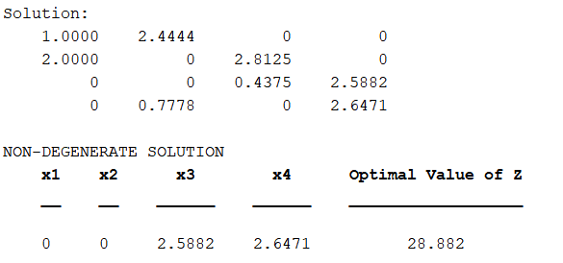

**Question 2**

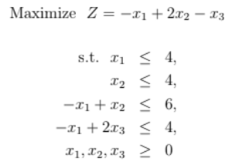

**Code:**

%% QUESTION 2

% TO OBTAIN BFS USING ALGEBRAIC METHOD

% Question 2

% Max Z= -x1+2x2-x3

% st: x1+s1=4

% x2+s2=4

% -x1+x2+s3=6

% -x1+2x3+s4=4

% x1,x2,x3>=0

clc

clear all

format short

% PHASE-1: Input the parameter

c=[-1,2,-1,0,0,0,0]; %Objective function

A=[1,0,0,1,0,0,0;0,1,0,0,1,0,0;-1,1,0,0,0,1,0;-1,0,2,0,0,0,1]; %Coefficient Matrix

B=[4;4;6;4];%RHS of const

objective=1; %1 for max and -1 for minimization problem

%Number of possible solutions: nCm:nchoosek

% PHASE-2: Number of constraint and variable

m=size(A,1); %number of constraints

n=size(A,2); % number of variables

% PHASE-3: Compute the ncm Basic Solutions: The max number of basic

% solutions will always be nCm

nab=nchoosek(n,m); %total number of atmost basic solution

t=nchoosek(1:n,m); %from this we can extract our set of variables that we need to equate to zero

% PHASE-4:Construct the basic solution

% for this n>m must be satisfied

sol=[]; %default solution is zero (Empty Matrix)

if n>=m %if this is not statisfied then we can not have solutions

for i = 1:nab

y = zeros(n, 1);

% Check if the selected variables form a singular matrix

if rank(A(:, t(i, :))) == m

X = A(:, t(i, :)) \ B; % Solve for basic variables

if all(X >= 0)

y(t(i, :)) = X;

sol = [sol y];

end

end

end

disp("Solution: ");

disp(sol);

else

error('No. of variables is less than number of constraints')

end

if any(X == 0)

fprintf("DEGENERATE SOLUTION");

else

fprintf('NON-DEGENERATE SOLUTION\n');

end

%PHASE 5: To find optimal solution

Z=c*sol; %finding the values corresponding to each point

if(objective==1)

[Zmax,Zindex]=max(Z);%storing the max value of Z and the col in which this max value resides

else

[Zmax,Zindex]=min(Z);%storing the min value of Z and the col in which this min value resides

end

BFS=sol(:,Zindex);%basic feasible solution

[Optimal_Value]=[BFS' Zmax];

Optimal_bfs=array2table(Optimal_Value);

Optimal_bfs.Properties.VariableNames(1:size(Optimal_bfs,2))={'x1','x2','x3','s1','s2','s3','s4','Optimal Value of Z'};

disp(Optimal_bfs);

**Output:**

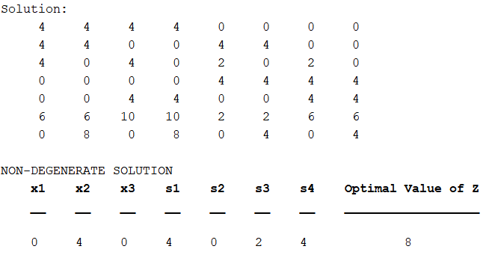

**Question 3:**

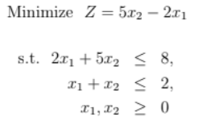

**Code:**

%% QUESTION 3

% TO OBTAIN BFS USING ALGEBRAIC METHOD

% Question

% Min Z= 5x2-2x1

% st: 2x1+5x2+s1=8

% x1+x2+s2=2

% %xi>=0

clc

clear all

format short

% PHASE-1: Input the parameter

c=[-2,5,0,0]; %Objective function

A=[2,5,1,0;1,1,0,1]; %Coefficient Matrix

B=[8;2];%RHS of const

objective=-1; %1 for max and -1 for minimization problem

%Number of possible solutions: nCm:nchoosek

% PHASE-2: Number of constraint and variable

m=size(A,1); %number of constraints

n=size(A,2); % number of variables

% PHASE-3: Compute the ncm Basic Solutions: The max number of basic

% solutions will always be nCm

nab=nchoosek(n,m); %total number of atmost basic solution

t=nchoosek(1:n,m); %from this we can extract our set of variables that we need to equate to zero

% PHASE-4:Construct the basic solution

% for this n>m must be satisfied

sol=[]; %default solution is zero (Empty Matrix)

if n>=m %if this is not statisfied then we can not have solutions

for i=1:nab

y=zeros(n,1);

%selecting all rows for a specific column where for t we are taking all columns for a

% specific row (which is basically the variables that are equated to zero)

X=(A(:,t(i,:)))\B;

%fetching values from A matrix for the rows correspond

%checking feasibility condition

if all(X>=0 & X~=inf & X~=-inf)

y(t(i,:))=X;

sol=[sol y];

end

end

disp("Solution: ");

disp(sol);

else

error('No. of variables is less than number of constraints')

end

if any(X == 0)

fprintf("DEGENERATE SOLUTION\n");

else

fprintf('NON-DEGENERATE SOLUTION\n');

end

%PHASE 5: To find optimal solution

Z=c*sol; %finding the values corresponding to each point

if(objective==1)

[Zmax,Zindex]=max(Z);%storing the max value of Z and the col in which this max value resides

else

[Zmax,Zindex]=min(Z);%storing the min value of Z and the col in which this min value resides

end

%Optimal BFS

BFS=sol(:,Zindex);%basic feasible solution

[Optimal_Value]=[BFS' Zmax];

Optimal_bfs=array2table(Optimal_Value);

Optimal_bfs.Properties.VariableNames(1:size(Optimal_bfs,2))={'x1','x2','s1','s2','Optimal Value of Z'};

disp(Optimal_bfs);

**Output:**

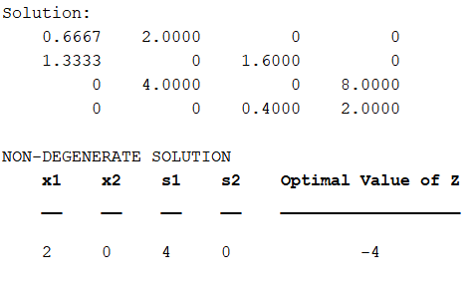

**Question 4:**

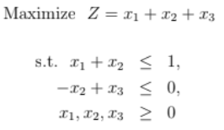

**Code:**

%% QUESTION 4

% TO OBTAIN BFS USING ALGEBRAIC METHOD

% Question

% Max Z= x1+x2+x3+0s1+0s2

% st: x1+x2+s1=1

% -x2+x3+s2=0

% %xi>=0

clc

clear all

format short

% PHASE-1: Input the parameter

c=[1,1,1,0,0]; %Objective function

A=[1,1,0,1,0;0,-1,1,0,1]; %Coefficient Matrix

B=[1;0];%RHS of const

objective=1; %1 for max and -1 for minimization problem

%Number of possible solutions: nCm:nchoosek

% PHASE-2: Number of constraint and variable

m=size(A,1); %number of constraints

n=size(A,2); % number of variables

% PHASE-3: Compute the ncm Basic Solutions: The max number of basic

% solutions will always be nCm

nab=nchoosek(n,m); %total number of atmost basic solution

t=nchoosek(1:n,m); %from this we can extract our set of variables that we need to equate to zero

% PHASE-4:Construct the basic solution

% for this n>m must be satisfied

sol=[]; %default solution is zero (Empty Matrix)

if n>=m %if this is not statisfied then we can not have solutions

for i = 1:nab

y = zeros(n, 1);

% Check if the selected variables form a singular matrix

if rank(A(:, t(i, :))) == m

X = A(:, t(i, :)) \ B; % Solve for basic variables

if all(X >= 0)

y(t(i, :)) = X;

sol = [sol y];

end

end

end

disp("Solution: ");

disp(sol);

else

error('No. of variables is less than number of constraints')

end

if any(X == 0)

fprintf("DEGENERATE SOLUTION\n");

else

fprintf('NON-DEGENERATE SOLUTION\n');

end

%PHASE 5: To find optimal solution

Z=c*sol; %finding the values corresponding to each point

if(objective==1)

[Zmax,Zindex]=max(Z);%storing the max value of Z and the col in which this max value resides

else

[Zmax,Zindex]=min(Z);%storing the min value of Z and the col in which this min value resides

end

BFS=sol(:,Zindex);%basic feasible solution

[Optimal_Value]=[BFS' Zmax];

Optimal_bfs=array2table(Optimal_Value);

Optimal_bfs.Properties.VariableNames(1:size(Optimal_bfs,2))={'x1','x2','x3','s1','s2','Optimal Value of Z'};

disp(Optimal_bfs);

**Output:**

